Aishwarya Allam

Web Application Part 3

Git Hub Repo: <https://github.com/aishwaryaallam/OscarFemaleAges>

Data in Pycharm

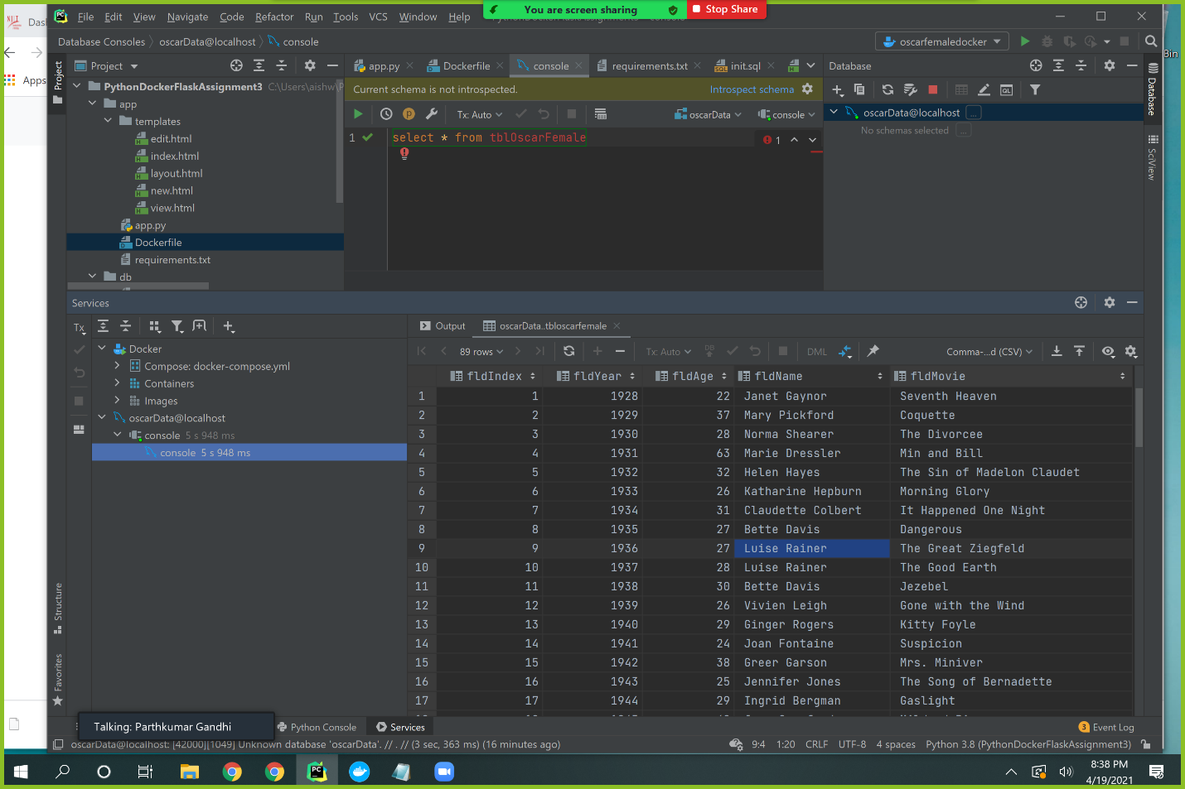

Data on web browser

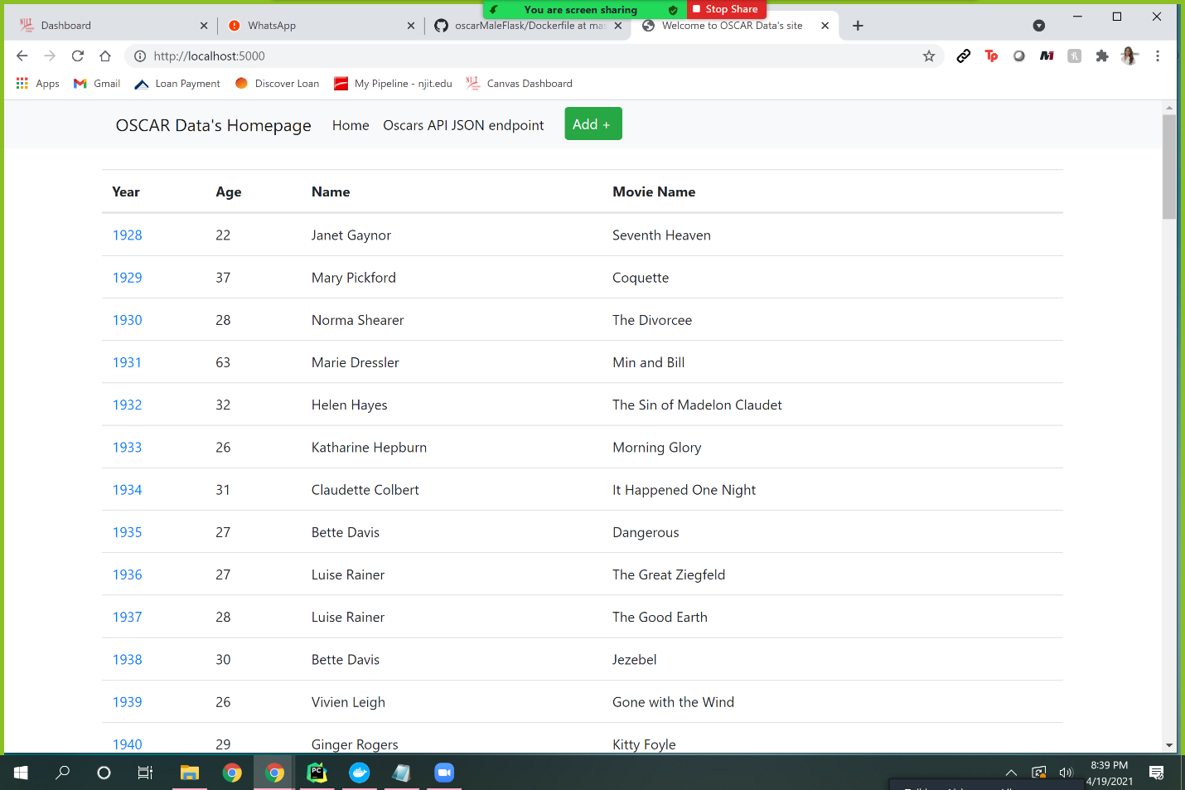

Data Entry edit option

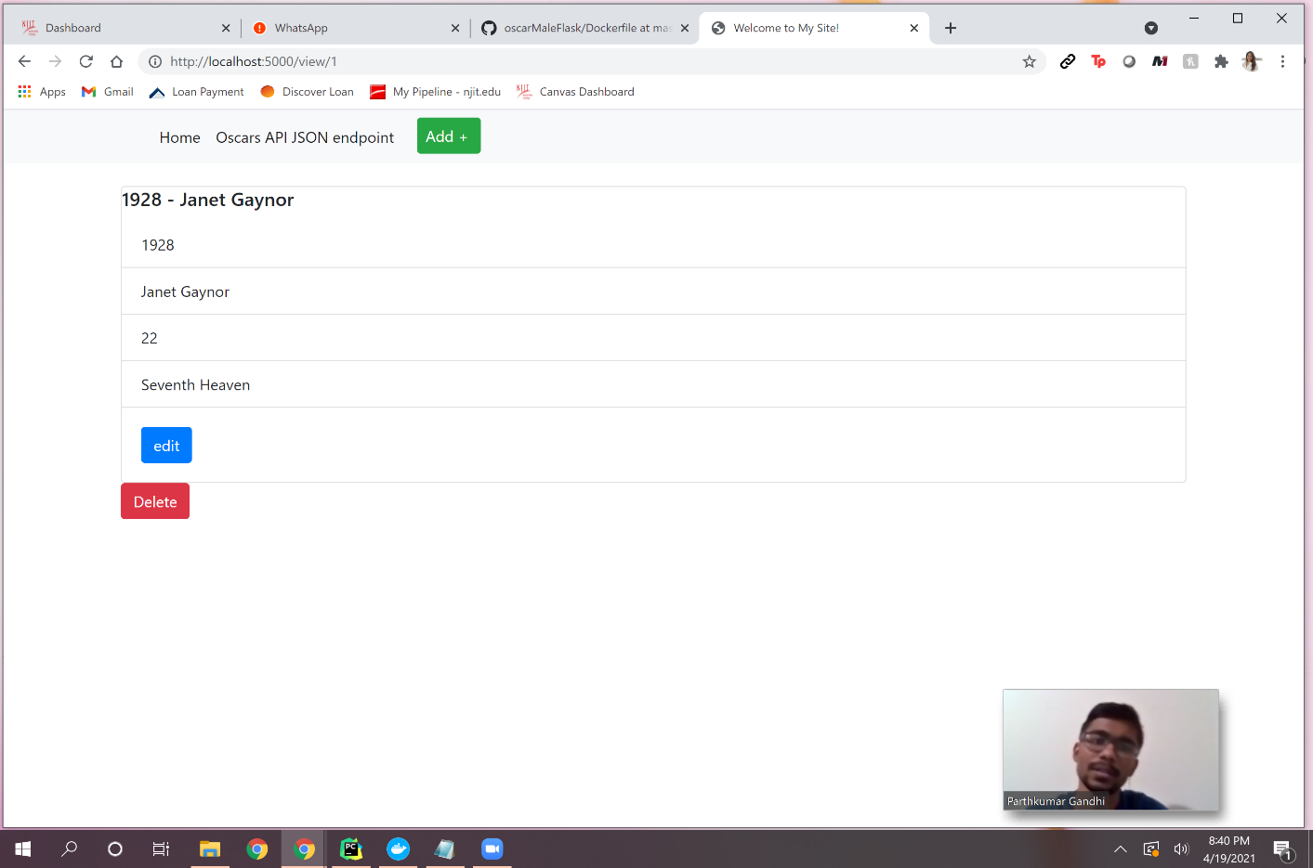

Added new data entry

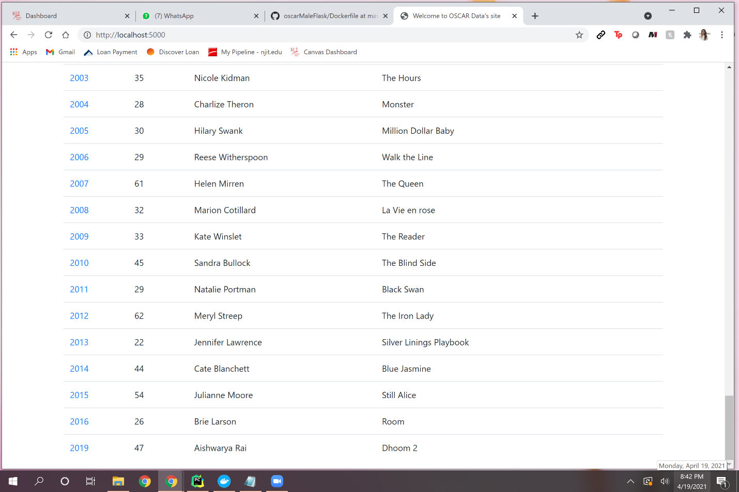

Edited Data entry to different movie

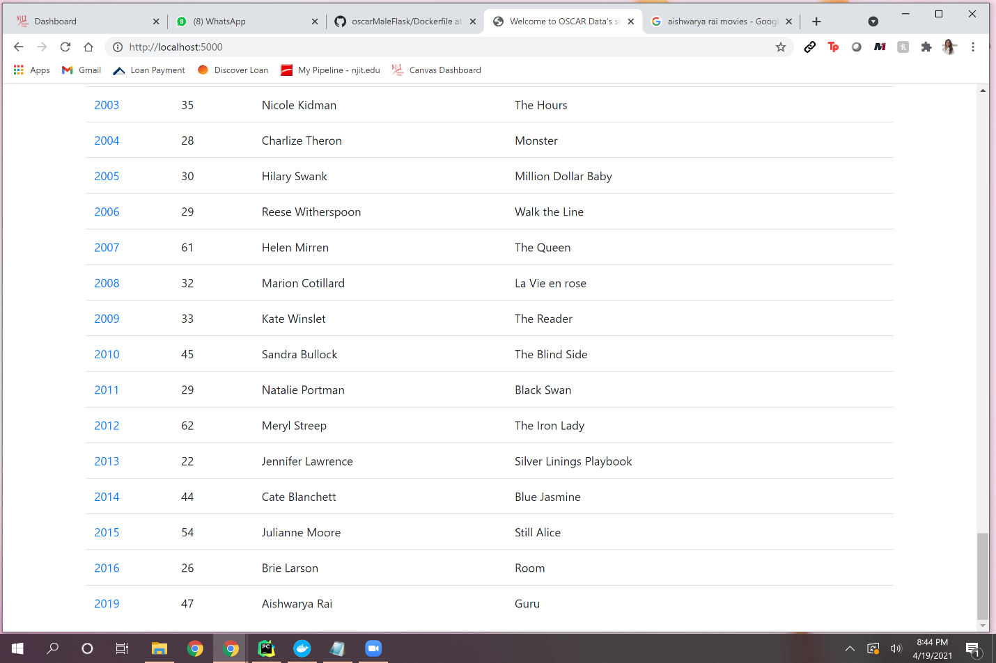

Deleted data entry

